FAIRFIELD JOINT WATER AND SEWER SYSTEM
350 Columbia Road Winnsboro, SC 29180
803-635-1620
FREEDOM OF INFORMATION ACT REQUEST FORM
The Fairfield Joint Water and Sewer System (the "Fairfield Joint System") has adopted its "Policy Regarding Requests for Public Records Under the Freedom of Information Act" (the "Policy"). Pursuant to the Policy, requests for information made under the Freedom of Information Act, codified at Title 6, Chapter 25 of the Code of Laws of South Carolina 1976, as amended ("FOIA"), shall be made using this form. This form must be signed and submitted either (i) in person at the offices of the Fairfield Joint System, which are the administrative offices of Fairfield County, South Carolina, located at 350 Columbia Road, Winnsboro, SC 29180; (ii) by mail to Fairfield Joint Water and Sewer System c/o Fairfield County Attn: Secretary, 350 Columbia Road Winnsboro, SC 29180; or (iii) by electronic mail to Patti.Davis@fairfield.sc.gov. Additional fees may also be charged. Requests should not be faxed.
NAME: DATE OF REQUEST:. _
ADDRESS: _
CITY:. STATE:. ZIP: _ PHONE NUMBER: EMAIL: _
I, the undersigned, agree to pay the charges set by the fee schedule below for the services and copies I have requested. SIGNATURE=---------------------------------------

INFORMATION REQUESTED (please be as specific as possible and attach additional pages, if needed):

Section 30-4-30(b) of FOIA authorizes the Fairfield .Joint System, as a public body, to charge and collect fees for the actual costs of responding to requests for public information. The Fairfield Joint System has duly adopted the fee schedule set forth below for copies and for staff time in searching for and providing requested information. An additional deposit is required for requests that are anticipated to require greater than (5) five hours of staff time.
PURSUANT TO § 30-2-50 OF THE CODE OF LAWS OF SOUTH CAROLINA 1976, AS AMENDED, YOU ARE PROHIBITED FROM KNOWINGLY USING PUBLIC RECORDS OBTAINED FROM THE FAIRFIELD JOINT WATER AND SEWER SYSTEM FOR COMMERCIAL SOLICITATION. VIOLATION OF THIS LAW IS PUNISHABLE AS A MISDEMEANOR, RESULTING IN UP TO A YEAR IN PRISON OR A FINE NOT TO EXCEED
$500. MY FILING OF THIS REQUEST CONSITUTES ACKNOWLEDGMENT OF THIS PROHIBITION.

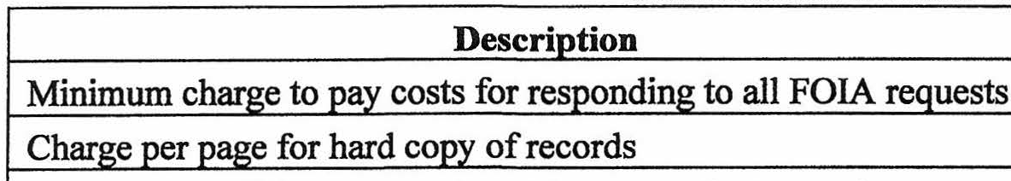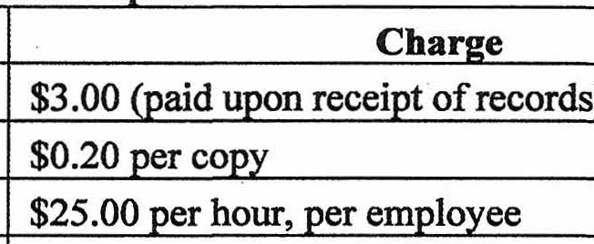
Char e for other media used to rovide records
Deposit for anticipated or apparent staff time exceeding 5 hours
Y4 of estimated costs
Fee Schedule for Staff Time and Co ies
Char e for staff time to search, retrieve, or redact records
Actual cost of media to the Fairfield Joint S stem

FOR SYSTEM USE ONLY
, ' CEIVED BY: DATE RECEIVED:. _
\.
."ASSIGNED TO: DATE RESPONSE DUE: _

